This document provides some insides of the dataset analysis done by picking a dataset named as “BIGBASKET PRODUCT” from “KAGGLE.COM” .

1. Which dataset you've selected?

The dataset I have selected is “BIGBASKET PRODUCT” which is a dataset that have all the sample data of an mart including different sort of products with their prizes.

1. What analysis you've done in the starter code?

The analysis I have from the following code are as following :

* The code have imported some libraries such as pandas, numpy ,seaborn ,plotly etc for the external function performance.
* The dataset is saved on Microsoft excel and have the following details about each product including product name ,category, sub category , brand , market price , sale price , type rating description.
* The code involves some graphs , tables that shows certain information differently presented .for example:

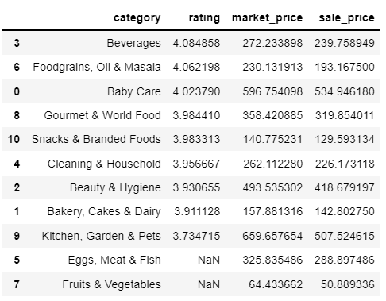

**The following table display only four attributes including category , rating , market price , sale price of certain products for analysis .**

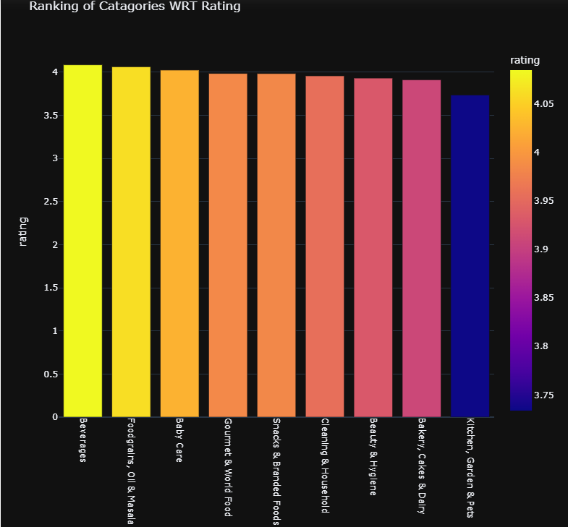

**The following is the example of a graph that indicates the ranking of some product type on the right is given a color shade card that specifies color ranges at a specific rank . for example baby care is indicated by a shade of yellow color on the shade indicator and have rating of 4.**

* Many graphs according to the specifications are uniquely created and specified for analysis .

1. What information you got?

The information I got is how to classify large amount of Data into several categories and sort the data by using tables and graphs to make it more useful.